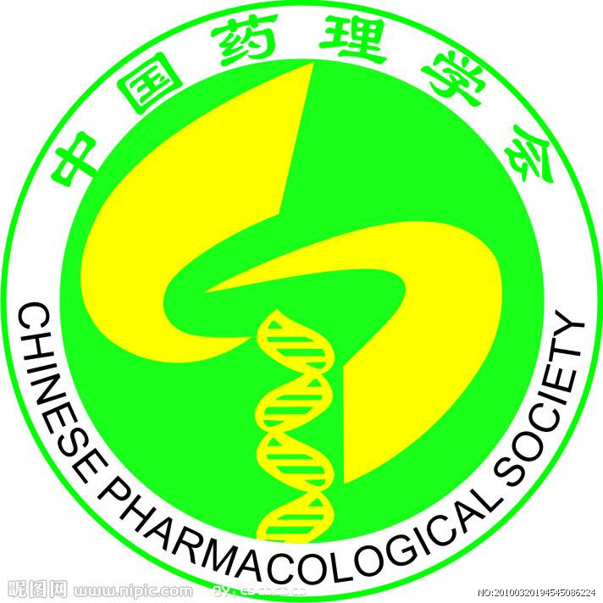
中国药理学会
中国药理学会北美分会

Chinese Pharmacological Society North American Chapter Conference
Toronto, Canada June 25-30, 2017

Name, degree, job/position title、
Dept, institute,
Address
Email,
Tel & Fax #

March 08, 2017

2017 Chinese Pharmacological Society North American Chapter Conference, Toronto, Canada

Dear Professor or Dr. xxx,

On behalf of the 2017 Chinese Pharmacological Society North American Chapter (CPS-NAC) Conference Organizing Committee, I would like to invite you to attend the 2017 CPS-NAC Conference, and consider presenting your research work at this prestigious event.

The CPS-NAC Conference will take place at the University of Toronto (Toronto, Canada) from June 25th to 30th, 2017. This conference will provide a new platform for Chinese, Canadian, USA and other international scientists to present and discuss their work in the field of Pharmacology and Physiology, facilitating cutting edge research through the sharing of ideas and/or the initiation of new research collaborations. The conference is organized by the Chinese Pharmacological Society (CNPHARS) and CPS-NAC.

The scientific program will begin on June 26th (Monday) at the University of Toronto St. George Campus followed by the registration on June 25th. The scientific program includes daily morning and afternoon oral presentation sessions covering current topics in pharmacology, physiology and related disciplines, as well as poster presentations from June 26th to 28th. An opening welcome banquet is scheduled for Monday evening, June 26th. There will be break-out group activities from June 29th to 30th, including round table discussion sessions to promote collaborations and knowledge exchange in pharmacology research and education.

Please visit the CNPHARS conference website for more information: http://www.cnphars.org/view.asp?ar_id=1220&anclassid=7&nclassid=

Yours sincerely

Professor Dayue Darrel Duan, Chairmen, Chinese Pharmacological Society North American Chapter
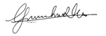
Professor Guan-hua Du, President, Chinese Pharmacological Society

Chinese Pharmacological Society
Room 334, New Building, No 1 Xian Nong Tan Street, Xicheng District, Beijing, China
Telephone: 86-10-63165211 Fax: 86-10-63165211
E-mail: muxin@imm.ac.cn; zhaoying@imm.ac.cn;zhxd@imm.ac.cn

